July 2026

Update the following Backlinks performance in the dashboard by considering the following parameters

Update the Number of URLS tracked, Total backlinks planned for the month July and Actual backlinks acquired in month July and Number of keywords tracked to track the performance
URLs Tracked - 42
PLAN TOTAL BACKLINKS (Jul) - 930
Actual Total Backlinks (July) - 678
Keywords Tracked - 75

Here is the Referring DA categories of the given backlinks
Referring Domain DA
DA 71 - 100 - 69
DA 41–70: 462
DA 30–40: 147

Business Impact of Backlinks

1. Impact on Keywords Where Backlinks Are Acquired

Keywords in Top 3 Positions
Dec’25 - 5
July’26 - 15

Keywords on First Page
Dec’25 - 26
July'26 - 37

2. Impact on Overall Keyword Rankings Graph
Page 1 Baseline - 41683 July - 44846(Row 16)
Position 1 Baseline - 6085 July - 7171(Row 13)
Position 2 & 3 Baseline - 10662 July - 11911 (Row 14)

Backlink Growth Analysis

Here are the all Page URLs tracked

- https://www.fortinet.com/resources/cyberglossary/what-is-ztna
- https://www.fortinet.com/resources/cyberglossary/what-is-network-security
- https://www.fortinet.com/resources/cyberglossary/what-is-cybersecurity
- https://www.fortinet.com/resources/cyberglossary/sd-wan-explained
- https://www.fortinet.com/resources/cyberglossary/sase
- https://www.fortinet.com/resources/cyberglossary/firewall
- https://www.fortinet.com/resources/cyberglossary/what-is-cyber-attack
- https://www.fortinet.com/solutions/industries/scada-industrial-control-systems/what-is-ot-security
- https://www.fortinet.com/products/sd-wan
- https://www.fortinet.com/resources/cyberglossary/what-is-secops
- https://www.fortinet.com/resources/cyberglossary/ransomware
- https://www.fortinet.com/resources/hubs/quantum-security
- https://www.fortinet.com/resources/cyberglossary/what-is-cloud-security
- https://www.fortinet.com/resources/cyberglossary/casb
- https://www.fortinet.com/solutions/enterprise-midsize-business/fortiai
- https://www.fortinet.com/resources/cyberglossary/ai-security
- https://www.fortinet.com/resources/cyberglossary/cyber-threat-intelligence
- https://www.fortinet.com/resources/cyberglossary/artificial-intelligence-in-cybersecurity
- https://www.fortinet.com/resources/cyberglossary/application-security
- https://www.fortinet.com/resources/cyberglossary/cloud-data-protection
- https://www.fortinet.com/resources/cyberglossary/privileged-access-management
- https://www.fortinet.com/
- https://www.fortinet.com/blog/industry-trends/quantum-safe-encryption-safeguarding-data-for-the-quantum-era
- https://www.fortinet.com/blog/business-and-technology/cyber-risk-is-a-business-risk
- https://www.fortinet.com/blog/industry-trends/cybersecurity-in-banking
- https://www.fortinet.com/resources/articles/best-cloud-security-providers
- https://www.fortinet.com/resources/cyberglossary/network-monitoring
- https://www.fortinet.com/resources/cyberglossary/shors-grovers-algorithms
- https://www.fortinet.com/resources/cyberglossary/post-quantum-cryptography
- https://www.fortinet.com/resources/cyberglossary/quantum-computing-security
- https://www.fortinet.com/resources/cyberglossary/quantum-key-distribution
- https://www.fortinet.com/resources/cyberglossary/quantum-safe-security
- https://www.fortinet.com/resources/cyberglossary/quantum-security
- https://www.fortinet.com/resources/cyberglossary/what-is-soc
- https://www.fortinet.com/solutions/unified-sase
- https://www.fortinet.com/products/rugged
- https://www.fortinet.com/resources/cyberglossary/what-is-zero-trust
- https://www.fortinet.com/solutions/ai-security
- https://www.fortinet.com/solutions/cloud-security/enterprise
- https://www.fortinet.com/resources/cyberglossary/what-is-soar
- https://www.fortinet.com/products/siem/fortisiem
- https://www.fortinet.com/solutions/security-operations

Here are the Months they are tracked for
Jan’26 Feb’26 Mar’26 Apr’26 May’26Jun’26Jul’26
Here are the Total Backlinks added respectively with the month
50
153
211
285
390
425
678

Keyword Ranking Performance
Keywords in the Top 3 Positions after acquiring the backlinks in the month
Dec 2025 - 5
Jul 2026- 15

Position change data - For the table below
Dec 2025
what is ztna 7
What is SD WAN 8
sase 7
what is sase 11
firewall 7
what is cyber attack 8
what is ot security 8
ot security 9
what is secops 22
AI Cybersecurity 3
role of ai in cyber security 101
Quantum Computing Security 101
Quantum Safe Security 3
Unified SASE 1
Ruggedized firewall 101

Keywords in Top 3 Positions after acquiring the backlinks in month
July 2026
what is ztna 2
What is SD WAN 3
sase 2
what is sase 2
firewall 2
what is cyber attack 3
what is ot security 2
ot security 2
what is secops 2
AI Cybersecurity 2
role of ai in cyber security 1
Quantum Computing Security 1
Quantum Safe Security 1
Unified SASE 3
Ruggedized firewall 1
Keywords on first page after acquiring the backlinks in month
Dec’2025 - 26
June’ 2026- 37
Position Change Data - For the below table
Keywords on first page after acquiring the backlinks in month
Dec 2025
what is ztna 7
ZTNA 16
what is network security 15
cybersecurity 10
What is SD WAN 8
sd wan 6
sase 7
what is sase 11
firewall 7
what is firewall 8
what is cyber attack 8
cyber attack 7
what is ot security 8
ot security 9
what is secops 22
secops 14
what is ransomware 9
ransomware 7
casb 10
casb security 18
AI Security systems 8
AI Cybersecurity 3
role of ai in cyber security 101
Application security definition 14
PAM 5
cybersecurity in banking 101
cloud security vendors 9
cloud security providers 5
network monitoring system 29
Post-Quantum Cryptography 1
Quantum Computing Security 101
Quantum Key Distribution 4
Quantum Safe Security 3
Quantum Security 8
Unified SASE 1
Ruggedized firewall 101
siem products 10

July 2026 -
what is ztna 2
ZTNA 10
what is network security 5
cybersecurity 6
What is SD WAN 3
sd wan 5
sase 2
what is sase 2
firewall 2
what is firewall 5
what is cyber attack 3
cyber attack 8
what is ot security 2
ot security 2
what is secops 2
secops 9
what is ransomware 7
ransomware 8
casb 5
casb security 10
AI Security systems 6
AI Cybersecurity 2
role of ai in cyber security 1
Application security definition 7
PAM 7
cybersecurity in banking 7
cloud security vendors 5
cloud security providers 8
network monitoring system 4
Post-Quantum Cryptography 4
Quantum Computing Security 1
Quantum Key Distribution 4
Quantum Safe Security 1
Quantum Security 5
Unified SASE 3
Ruggedized firewall 1
siem products 10

Performance Summary Table
Update the summary table using this data
Page URLs (41 Page URLs)
- https://www.fortinet.com/resources/cyberglossary/what-is-ztna
- https://www.fortinet.com/resources/cyberglossary/what-is-network-security
- https://www.fortinet.com/resources/cyberglossary/what-is-cybersecurity
- https://www.fortinet.com/resources/cyberglossary/sd-wan-explained
- https://www.fortinet.com/resources/cyberglossary/sase
- https://www.fortinet.com/resources/cyberglossary/firewall
- https://www.fortinet.com/resources/cyberglossary/what-is-cyber-attack
- https://www.fortinet.com/solutions/industries/scada-industrial-control-systems/what-is-ot-security
- https://www.fortinet.com/products/sd-wan
- https://www.fortinet.com/resources/cyberglossary/what-is-secops
- https://www.fortinet.com/resources/cyberglossary/ransomware
- https://www.fortinet.com/resources/hubs/quantum-security
- https://www.fortinet.com/resources/cyberglossary/what-is-cloud-security
- https://www.fortinet.com/resources/cyberglossary/casb
- https://www.fortinet.com/solutions/enterprise-midsize-business/fortiai
- https://www.fortinet.com/resources/cyberglossary/ai-security
- https://www.fortinet.com/resources/cyberglossary/cyber-threat-intelligence
- https://www.fortinet.com/resources/cyberglossary/artificial-intelligence-in-cybersecurity
- https://www.fortinet.com/resources/cyberglossary/application-security
- https://www.fortinet.com/resources/cyberglossary/cloud-data-protection
- https://www.fortinet.com/resources/cyberglossary/privileged-access-management
- https://www.fortinet.com/
- https://www.fortinet.com/blog/industry-trends/quantum-safe-encryption-safeguarding-data-for-the-quantum-era
- https://www.fortinet.com/blog/business-and-technology/cyber-risk-is-a-business-risk
- https://www.fortinet.com/blog/industry-trends/cybersecurity-in-banking
- https://www.fortinet.com/resources/articles/best-cloud-security-providers
- https://www.fortinet.com/resources/cyberglossary/network-monitoring
- https://www.fortinet.com/resources/cyberglossary/shors-grovers-algorithms
- https://www.fortinet.com/resources/cyberglossary/post-quantum-cryptography
- https://www.fortinet.com/resources/cyberglossary/quantum-computing-security
- https://www.fortinet.com/resources/cyberglossary/quantum-key-distribution
- https://www.fortinet.com/resources/cyberglossary/quantum-safe-security
- https://www.fortinet.com/resources/cyberglossary/quantum-security
- https://www.fortinet.com/resources/cyberglossary/what-is-soc
- https://www.fortinet.com/solutions/unified-sase
- https://www.fortinet.com/products/rugged
- https://www.fortinet.com/resources/cyberglossary/what-is-zero-trust
- https://www.fortinet.com/solutions/ai-security
- https://www.fortinet.com/solutions/cloud-security/enterprise
- https://www.fortinet.com/resources/cyberglossary/what-is-soar
- https://www.fortinet.com/products/siem/fortisiem
- https://www.fortinet.com/solutions/security-operations

The below is the original data, I want you to add + next to Best Keyword Move column for all data in the dashboard (not here), also for Worst Keyword Move I want you to subtract last column and first column( ex: For ZTNA 8-33= -25) I want you to do the same for all the rows here as well
For the given above URLs here are the Total Backlinks, Ranking & Page Authority & Backlinks Added for months
Dec’25 Jan’26 Feb’26 Mar’26 Apr’26 May’26 June’26Jul’26
Total Baclinks 0 0 7 13 14 20 23 29
Backlink Added 0 0 7 6 1 7 2 6
what is ztna 7 10 6 5 3 3 2 2
ZTNA 16 10 12 11 7 10 13 10
Page Authority 48 48 53 53 53 53 53 53

Total Baclinks 0 0 3 5 8 11 11 17
Backlink Added 0 0 3 2 3 3 0 6
what is network security 15 11 7 4 3 2 4 5
network security 13 14 10 8 6 4 10 14
Page Authority 53 53 53 53 53 53 53 53

Total Baclinks 0 0 4 6 10 16 16 21
Backlink Added 0 0 4 2 4 6 0 5
what is cybersecurity 11 13 10 9 10 10 10 12
cybersecurity 10 10 8 6 5 6 10 6
Page Authority 52 52 52 52 53 53 53 53

Total Baclinks 0 1 6 6 11 15 16 26
Backlink Added 0 1 5 1 4 4 1 10
What is SD WAN 8 7 6 5 4 3 2 3
sd wan 6 5 5 5 4 3 4 5
Page Authority 55 55 55 55 55 55 55 55

Total Baclinks 0 1 5 12 16 22 24 31
Backlink Added 0 1 4 7 4 5 3 7
sase 7 8 5 5 2 2 2 2
what is sase 11 12 8 6 3 2 2 2
Page Authority 56 56 56 56 56 56 56 56

Total Baclinks 0 0 4 6 8 11 12 21
Backlink Added 0 0 4 2 2 3 1 9
firewall 7 7 6 4 3 2 3 2
what is firewall 8 6 4 5 3 3 4 5
Page Authority 56 56 55 55 56 56 56 56

Total Baclinks 0 1 1 1 1 1 1 1
Backlink Added 0 1 0 0 0 0 0 0
what is cyber attack 8 7 1 2 2 2 2 3
cyber attack 7 8 9 8 6 6 6 8
Page Authority 50 50 51 51 51 51 51 51

Total Baclinks 0 1 4 5 7 12 12 24
Backlink Added 0 1 3 1 2 5 0 12
what is ot security 8 9 4 2 1 1 2 2
ot security 9 9 5 4 2 2 2 2
Page Authority 55 55 55 55 55 55 55 55

Total Baclinks 0 1 1 1 1 5 5 13
Backlink Added 0 1 0 0 0 4 0 8
SD-WAN solutions 79 79 5 6 5 101 101 101
sdwan solutions 23 14 101 4 101 101 101 101
Page Authority 59 59 59 59 59 59 59 59

Total Baclinks 0 0 5 6 11 15 21 27
Backlink Added 0 0 5 1 5 5 5 6
what is secops 22 17 7 3 4 2 2 2
secops 14 11 7 6 6 7 9 9
Page Authority 48 48 49 49 50 50 50 50

Total Baclinks 0 2 2 2 2 2 2 2
Backlink Added 0 2 0 0 0 0 0 0
what is ransomware 9 8 7 7 8 8 6 7
ransomware 7 6 7 5 4 6 7 8
Page Authority 56 56 57 57 57 57 57 57

Total Baclinks 0 0 1 2 2 2 2 2
Backlink Added 0 0 1 1 0 0 0 0
quantum security solutions 101 101 101 101 101 101 101 101
quantum security 101 1 101 101 1 101 101 101
Page Authority 41 41 43 43 44 44 44 44

Page Authority 42 42 44 44 54 54 101 101
Total Baclinks 0 4 23 31 44 53 54 68
Backlink Added 0 4 19 8 13 9 1 14
what is cloud security 19 15 13 9 12 17 16 16
cloud security 17 17 18 14 16 19 21 19
Page Authority 49 49 51 51 52 52 52 52

Total Baclinks 0 2 2 2 2 2 2 2
Backlink Added 0 2 0 0 0 0 0 0
casb 10 9 7 4 5 4 6 5
casb security 18 18 9 4 6 8 8 10
Page Authority 49 49 49 49 50 50 50 50

Total Baclinks 0 2 2 2 2 2 3 8
Backlink Added 0 2 0 0 0 0 1 5
ai cybersecurity solutions 101 101 101 101 101 101 101 101
ai managed security 101 101 101 101 101 101 101 101
Page Authority 49 49 37 37 52 52 52 52

Total Baclinks 0 12 15 16 18 20 21 28
Backlink Added 0 12 3 1 2 2 0 8
AI Security 8 10 11 8 12 18 16 11
AI Security systems 8 8 17 9 10 8 6 6
Page Authority 52 52 53 53 53 53 53 53

Total Baclinks 0 12 12 12 12 12 12 12
Backlink Added 0 12 0 0 0 0 0 0
Threat Intelligence 25 23 31 18 18 16 18 19
Types of threat intelligence 101 101 101 28 101 101 101 42
Page Authority 48 48 49 49 49 49 49 49

Total Baclinks 0 0 6 8 12 16 23 41
Backlink Added 0 0 6 2 4 4 2 23
AI Cybersecurity 3 3 4 3 3 3 5 2
role of ai in cyber security 101 14 101 101 2 1 2 1
Page Authority 55 55 55 55 55 55 55 55

Total Baclinks 0 2 2 2 2 2 2 2
Backlink Added 0 2 0 0 0 0 0 0
Application Security 18 19 16 18 16 16 20 20
Application security definition 14 19 17 5 5 4 5 7
Page Authority 41 41 46 46 46 46 46 46

Total Baclinks 0 1 5 7 9 13 13 17
Backlink Added 0 1 4 2 2 4 0 4
Cloud Data Security 66 62 31 25 34 40 35 29
Data security in the cloud 33 52 14 8 45 49 45 42
Page Authority 43 43 46 46 47 47 47 47

Total Baclinks 0 4 4 4 4 4 4 4
Backlink Added 0 4 0 0 0 0 0 0
Privileged Access Management 12 14 16 10 13 13 12 12
PAM 5 6 3 6 101 101 5 7
Page Authority 48 48 48 48 48 48 48 48

Total Baclinks 0 1 2 2 3 8 8 16
Backlink Added 0 1 1 0 1 5 0 8
Cybersecurity 86 89 86 67 35 27 29 12
What is Cybersecurity 101 101 101 101 101 101 101 101
Page Authority 68 68 69 69 69 69 69 69

Total Baclinks 0 0 2 3 4 6 6 12
Backlink Added 0 0 2 1 1 2 0 6
Quantum safe encryption for crytography 101 101 101 101 101 101 101 101
Quantum secure encryption for crytography 101 101 101 101 101 101 101 101
Page Authority 60 60 47 47 47 47 47 47

Total Baclinks 0 2 2 2 2 2 2 2
Backlink Added 0 2 0 0 0 0 0 0
cyber risk 40 41 40 32 37 101 50 101
cyber risk is business risk 101 101 101 101 101 101 101 101
Page Authority 44 44 46 46 46 46 46 46

Total Baclinks 0 1 1 1 1 1 1 1
Backlink Added 0 1 0 0 0 0 0 0
cybersecurity in banking 101 30 30 12 21 25 29 7
banking cybersecurity 101 101 101 3 101 28 101 14
Page Authority 44 44 44 44 46 46 46 46

Total Baclinks 0 0 7 8 17 17 17 17
Backlink Added 0 0 7 1 9 0 0 0
cloud security vendors 9 7 11 6 8 7 8 5
cloud security providers 5 7 9 5 8 9 3 8
Page Authority 61 61 61 61 44 44 44 44

Total Baclinks 0 0 3 4 7 11 11 14
Backlink Added 0 0 3 1 3 4 0 3
network monitoring 21 19 11 7 8 12 13 11
network monitoring system 29 19 19 14 11 10 10 4
Page Authority 44 44 44 44 45 45 45 45

Total Baclinks 0 0 3 5 6 9 11 20
Backlink Added 0 0 3 2 1 3 2 9
shors grovers algorithms 101 101 101 101 101 101 101 101
shors algorithms 101 101 101 101 101 101 101 101
Page Authority 46 46 47 47 47 47 47 47

Total Baclinks 0 0 4 6 7 10 11 18
Backlink Added 0 0 4 2 1 3 1 7
Post-Quantum Cryptography 1 2 3 6 2 2 3 4
Page Authority 39 39 42 42 44 44 44 44

Total Baclinks 0 0 2 4 5 6 8 12
Backlink Added 0 0 2 2 1 1 1 5
Quantum Computing Security 101 4 5 6 101 7 4 1
Page Authority 46 47 47 47 47 47 47 47

Total Baclinks 0 0 1 5 5 6 10 15
Backlink Added 0 0 1 4 0 1 4 5
Quantum Key Distribution 4 8 8 5 4 5 5 4
Page Authority 61 61 61 61 44 44 44 44

Total Baclinks 0 0 2 3 5 7 8 12
Backlink Added 0 0 2 1 2 2 0 5
Quantum Safe Security 3 1 1 101 101 2 101 1
Page Authority 37 39 40 40 42 42 42 42

Total Baclinks 0 0 5 6 7 9 10 16
Backlink Added 0 0 4 2 1 2 1 6
Quantum Security 8 7 5 5 5 4 3 5
Page Authority 41 40 40 40 44 44 44 44

Total Baclinks 0 0 2 3 4 6 7 8
Backlink Added 0 0 2 1 1 2 1 1
Security Operation Centre 101 101 101 101 101 101 101 101
Page Authority 51 52 52 52 52 52 52 52

Total Baclinks 0 0 2 3 3 8 13 24
Backlink Added 0 0 2 1 0 6 4 11
Unified SASE 1 1 1 1 1 6 3 3
Page Authority 37 40 41 41 44 44 44 44

Total Baclinks 0 0 2 5 6 8 10 12
Backlink Added 0 0 2 3 1 2 2 2
Ruggedized firewall 101 101 101 101 101 1 1 1
industrial firewall 101 101 101 101 1 1 1 20
Page Authority 44 44 44 44 44 44

Total Baclinks 0 0 0 0 4 5 6 15
Backlink Added 0 0 0 0 4 1 1 9
What is Zero Trust 101 101 101 49
Zero trust 57 24 101 59
Page Authority 42 42 42 42 42 42

Total Baclinks 0 0 0 0 2 4 4 4
Backlink Added 0 0 0 0 2 2 0 0
AI Security 28 35 101 63
Page Authority 43 43 43 43 44 44

Total Baclinks 0 0 0 0 0 6 6 14
Backlink Added 0 0 0 0 0 6 0 8
Cloud Security Services 101 101 101 101 101 101 101 101
Page Authority 37 37 37 37 37 39 41 41

Total Baclinks 0 0 0 0 0 0 1 3
Backlink Added 0 0 0 0 0 0 1 2
soar automation 2 3 1 4 1 4 10 101
Page Authority 61 61 61 61 61 61 61 61

Total Baclinks 0 0 0 0 0 0 0 11
Backlink Added 0 0 0 0 0 0 0 11
siem software 15 12 11 9 4 6 11 15
siem products 8 12 9 8 8 10 9 10
siem solution 11 11 8 4 3 7 11 11
Page Authority 61 61 61 61 61 61 61 61

Total Baclinks 0 0 0 0 0 0 0 5
Backlink Added 0 0 0 0 0 0 0 5
security operations solution 101 101 101 101 101 101 101 101
secops solutions 101 101 101 101 101 101 101 101
Page Authority 37 37 37 41 43 43 42 43

Key Findings
Include key findings from the data Insights

- High-Quality Domain Profile: 68% of acquired domains fall in the DA 41–70 range (462 domains), representing the largest share of our portfolio. 21.7% are in the DA 30–40 range (147 domains). 10% are high authority DA 71–100 domains (69 domains).Summary: Over 78% of all referring domains are high-authority (DA 41+).
- Keyword Visibility:.Between December 2025 and July 2026, the keywords experienced significant growth in rankings, with Top 3 positions increasing by 200% (from 5 to 15) and Page 1 rankings improving by 42% (from 26 to 37).
- Page Authority (PA) as a Leading Indicator: Page Authority has improved for a few critical pages, such as ZTNA (48 → 53), Secops (48 → 50), Quantum Security (41 → 44), Cloud Security (49 → 52), Cloud Security ( 49 → 52), FortiAI (49 → 52) Cloud Data Protection (43 → 47), Application Security ( 41 → 46) & PQC ( 39 → 44).
- Significant Keywords Improvement: The keywords What is ZTNA (2), SASE (2), Firewall (2), what is cyber attack (3), OT Security (2), What is SecOps (2), AI Cybersecurity (2), Quantum Safe Security(1), Ruggedized firewall (1) showed significant improvement in search ranking.
- Strong Backlink Quality: 84.5% of acquired backlinks are indexed, indicating that the majority have been successfully discovered by search engines, reflecting strong backlink quality and healthy indexing performance.

Backlink Acquisition Details
Fortinet: Monthly Backlink 2026

SERP Key Highlights:
Priority Category pages - SD-Wan, Cyberattack, Secops, Cloud Security rank in Page 1 position after an improvement of positions due to backlinks
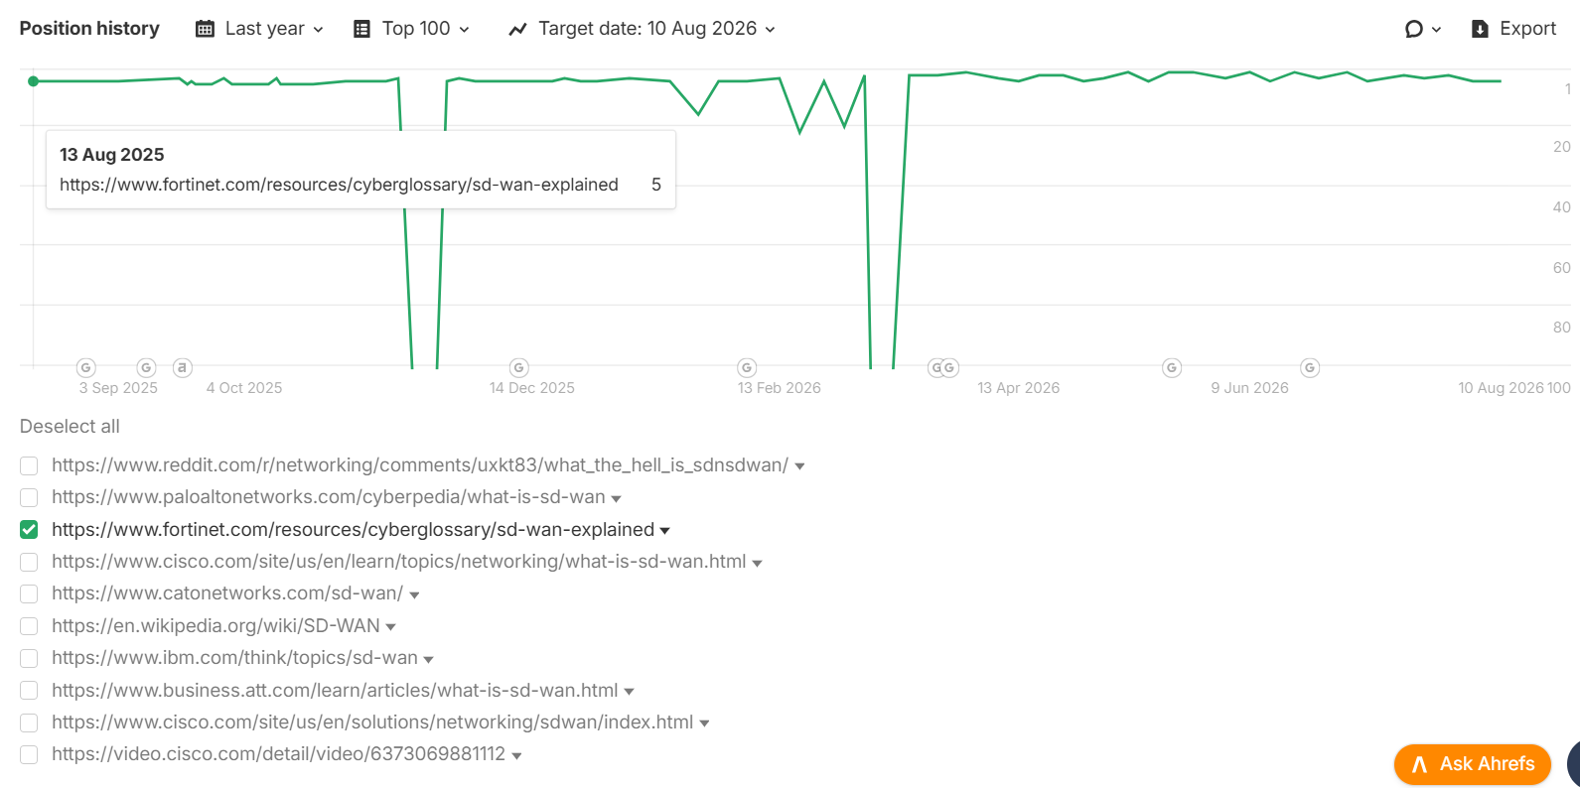Keyword- SD Wan
Link- https://www.fortinet.com/resources/cyberglossary/sd-wan-explained
Position- 2
Insight: The high-volume "SD-Wan" keyword (6K MSV) has maintained stable rankings following recent backlink acquisition, indicating improved ranking consistency and authority.
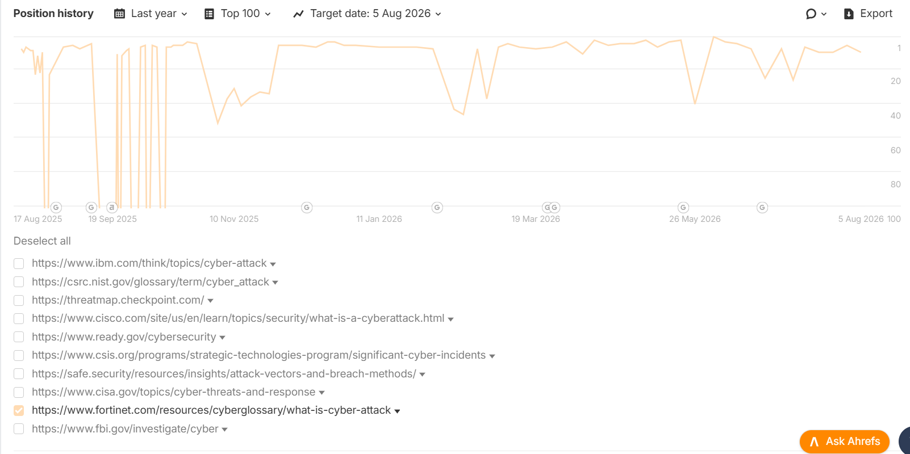Keyword - Cyber Attack
Link - https://www.fortinet.com/resources/cyberglossary/what-is-cyber-attack
Position - 9
Insight: Backlink acquisition has helped stabilize the previously volatile "Cyber Attack" keyword, improving ranking position.

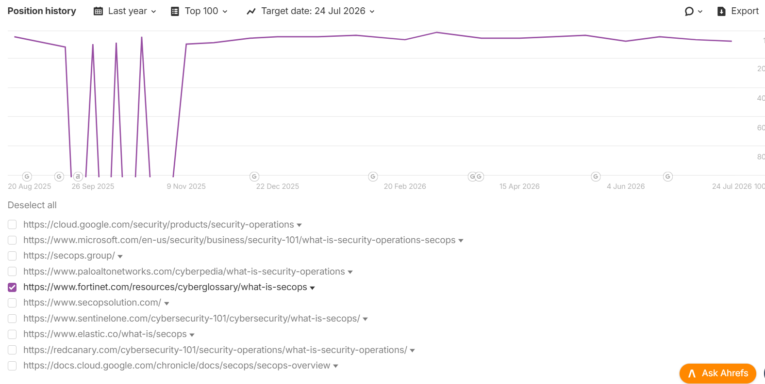
Keyword - Secops
Link - https://www.fortinet.com/resources/cyberglossary/what-is-secops
Position - 5
Insight: The high-volume "Secops" keyword (2K MSV) has started ranking in Top 5. Backlink acquisition has helped stabilize the previously volatile keyword.
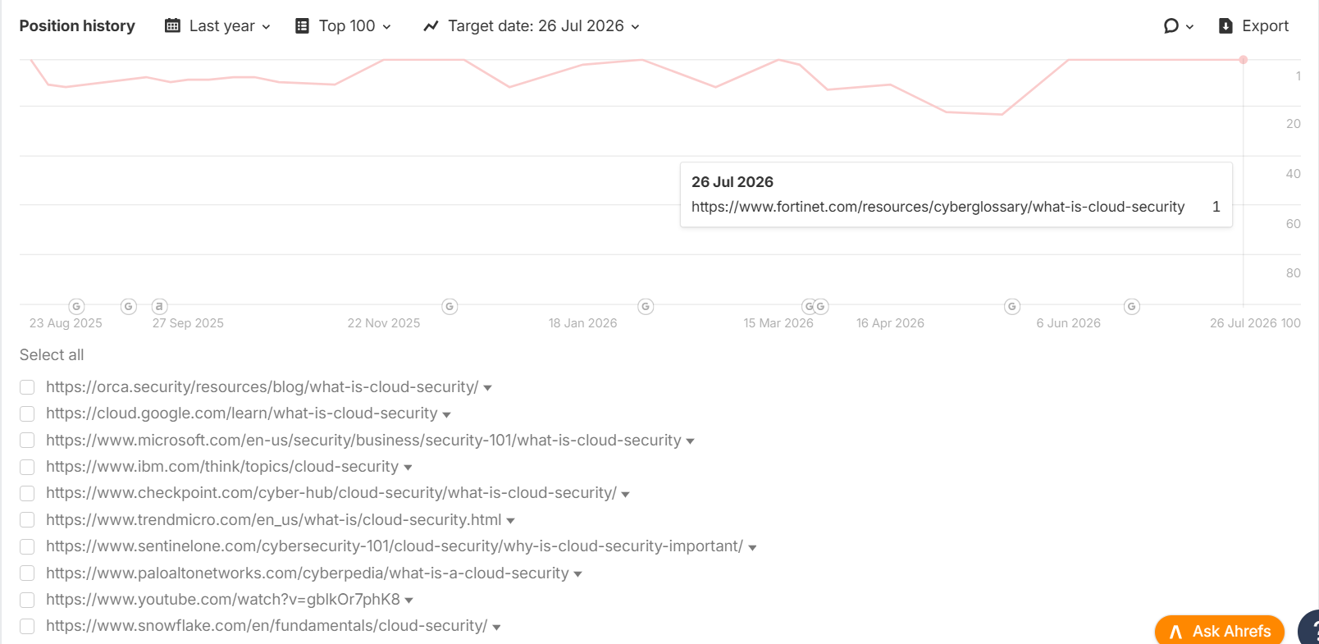
Keyword - What is Cloud Security
Link- https://www.fortinet.com/resources/cyberglossary/what-is-cloud-security
Position - 1
Insight: "What is Cloud Security" keyword (1.4K MSV), which had experienced significant ranking volatility, has now reached the #1 position following consistent efforts.

Top Categories - Quantum & AI Cybersecurity Cyberglossary pages rank in Top 3 position from Page 1 post efforts of backlinks.
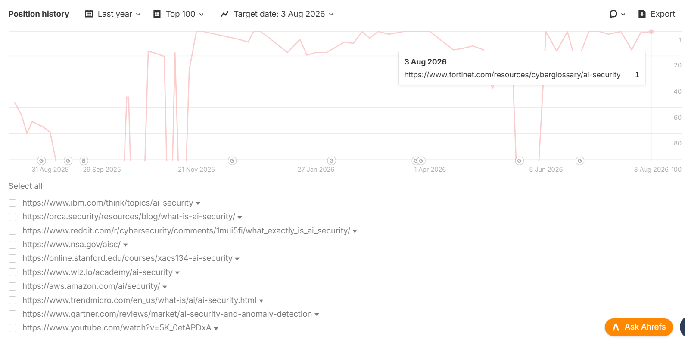
Keyword - AI Security
Link- https://www.fortinet.com/resources/cyberglossary/ai-security
Position - 1
Insight: The previously volatile "AI Security" keyword has now achieved stable #1 rankings, strengthening Fortinet's visibility in the AI Security Security category.

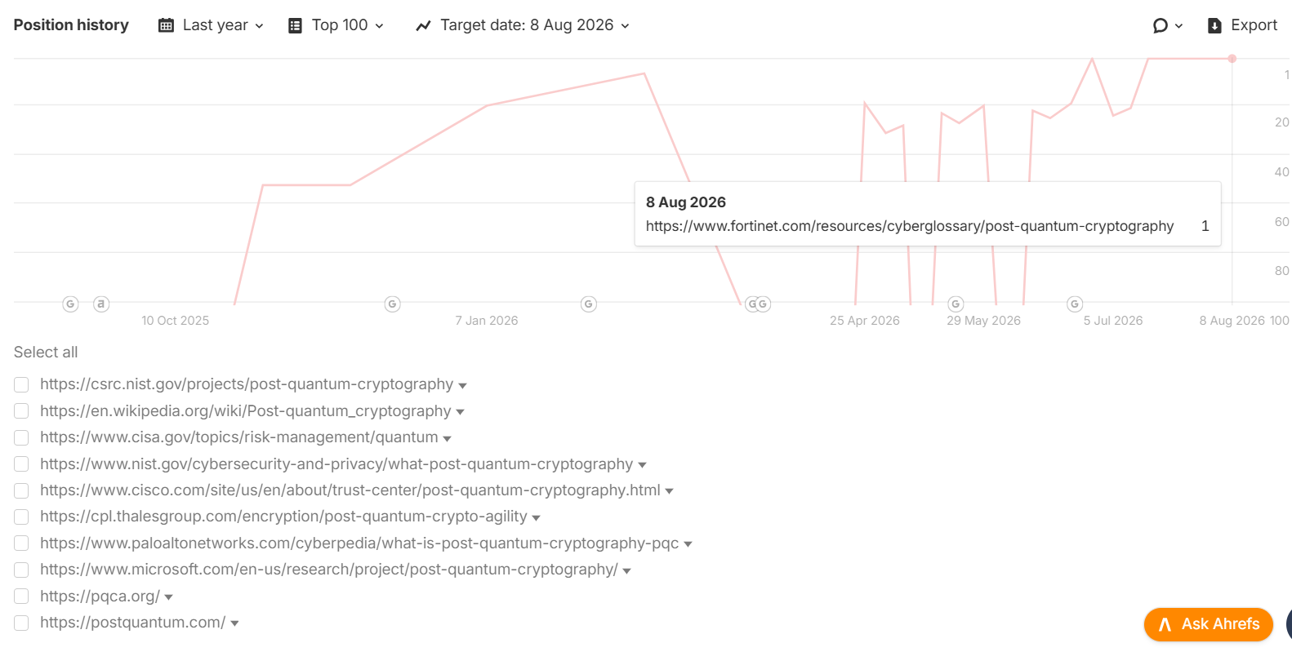
Keyword- Post-Quantum Cryptography
Link-https://www.fortinet.com/resources/cyberglossary/post-quantum-cryptography
Position- 1
Insight: The highly competitive "Post-Quantum Cryptography " keyword (Keyword Difficulty: 73) has improved from position #101 to Position 1, marking a significant gain in search visibility.
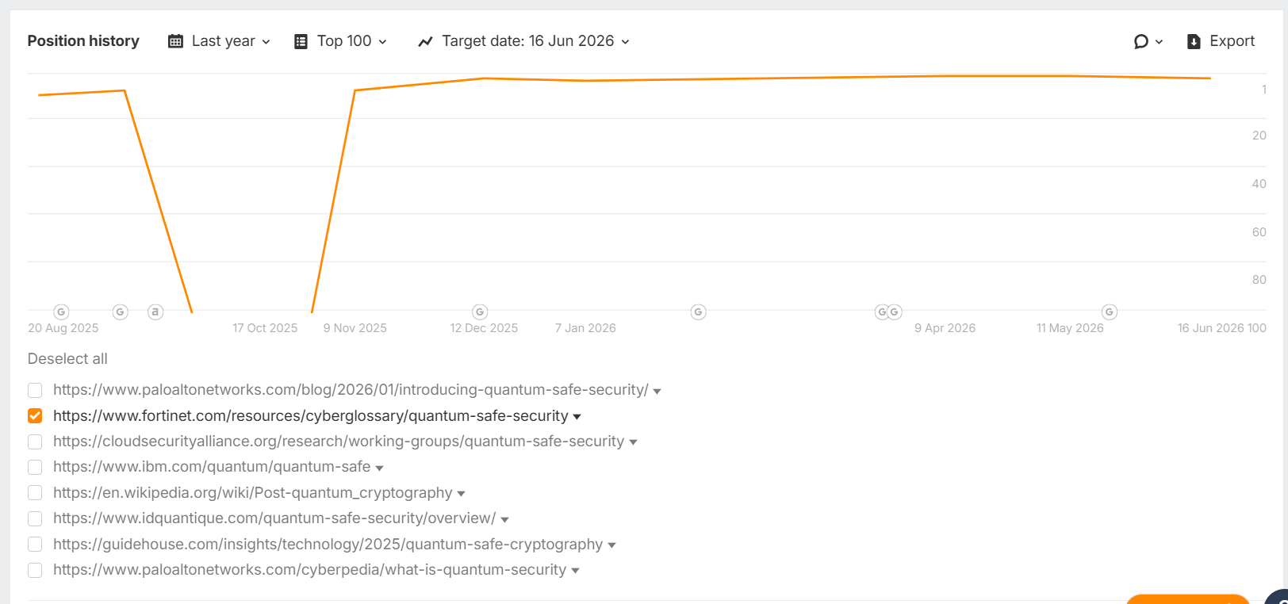
Keyword- Quantum Safe Security
Link- https://www.fortinet.com/resources/cyberglossary/quantum-safe-security
Position- 2
Insight: The "Quantum Safe Security" keyword has consistently maintained a Top 3 ranking, with sustained backlink efforts helping the page to rank from 101.

LLM Key Highlights:
Brand Visibility% Performance
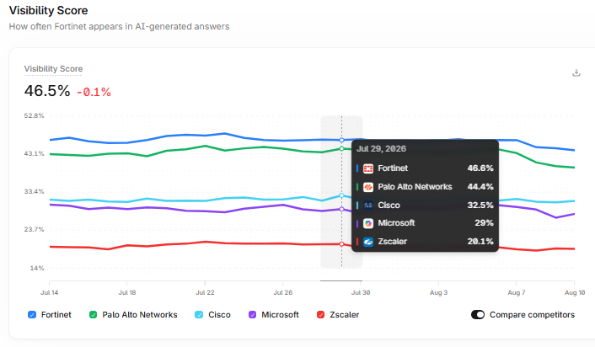Insight: Fortinet's overall brand visibility stands in position one among the competitors, indicating consistent improvement in AI/LLM search presence.

Category Brand Visibility Performance
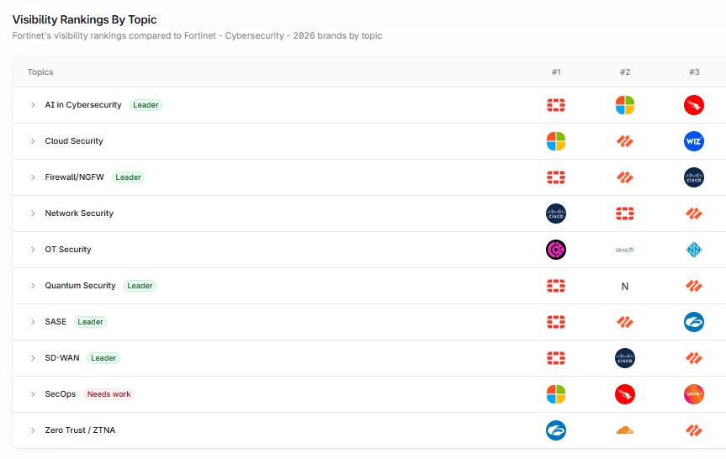
Insight:
- Fortinet leads in 5 out of 10 primary categories, achieving a 50% category leadership rate, demonstrating strong authority across the majority of key cybersecurity topics.

Category Matrix - Market Positioning
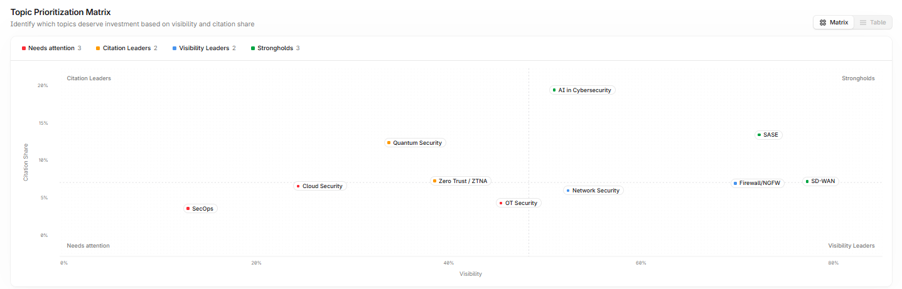Insight: Fortinet's LLM Marketing positioning
- Citation Leaders - Quantum Security & Zero Trust.
- Visibility Leaders - Network Security & Firewall
- Strongholds - AI in Cybersecurity, SASE & SD-Wan
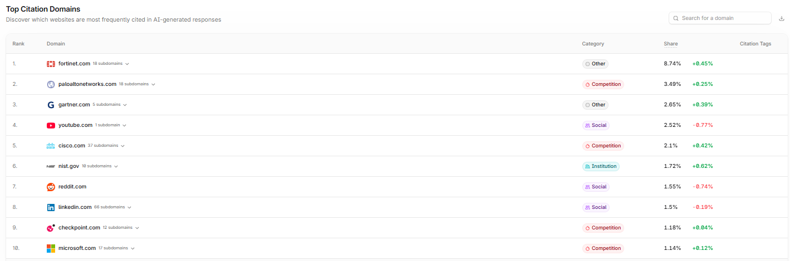Top citation domains landscape:
Insight: Fortinet ranks #1 in the citation domains with a share of 8.74%, outperforming Palo Alto Networks (3.49%) and maintaining a strong lead over all major competitors.
Listicle type of Guest Posts - Third-Party Guest Posts for Brand Mentions
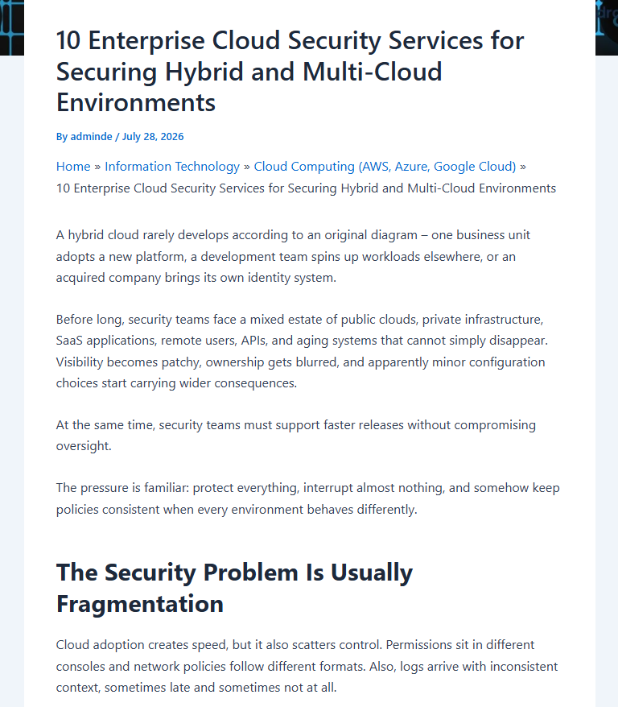
Full article - https://droven.io/cloud-security-services/

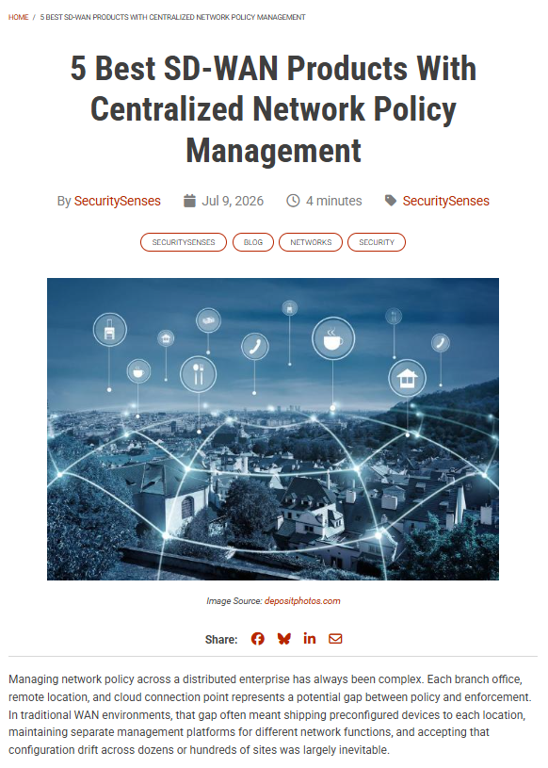 Full article - https://securitysenses.com/posts/5-best-sd-wan-products-centralized-network-policy-management
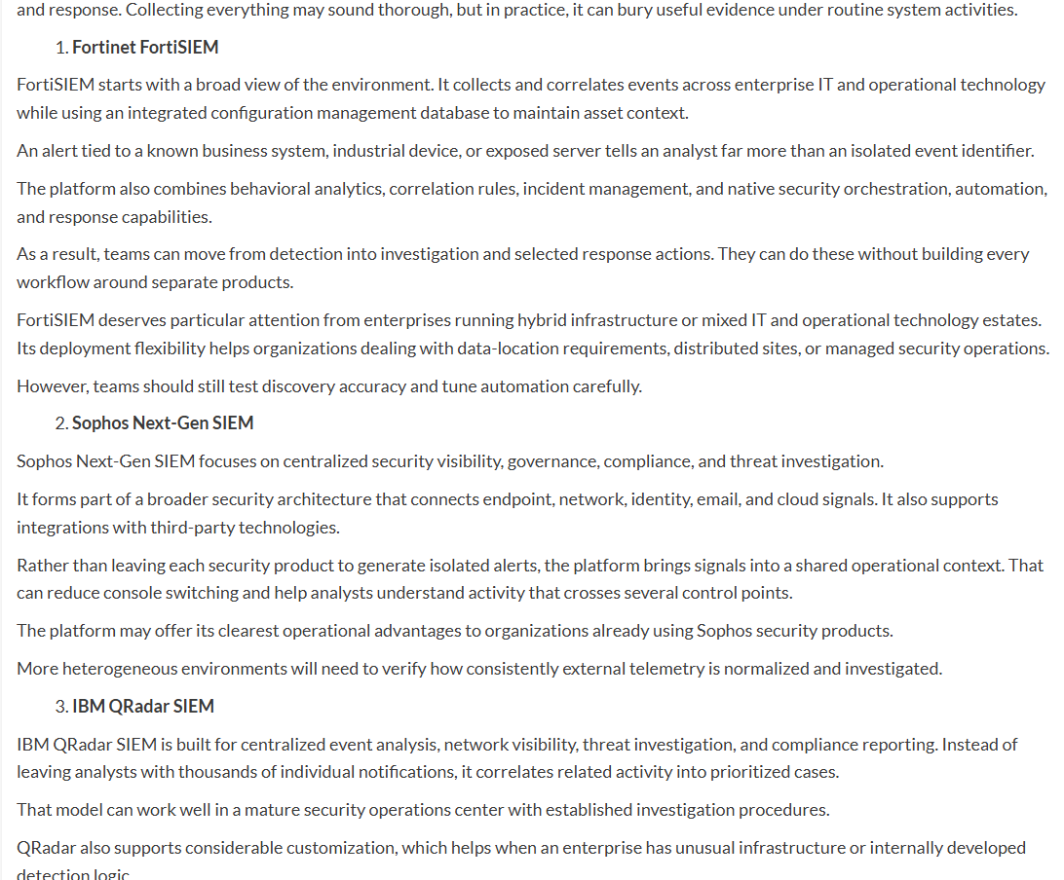Full Article - https://newsroompanama.com/2026/08/04/7-next-generation-siem-security-software-platforms-for-enterprise-threat-detection/
Insight: Publishing listicle-style ("Best"/"Top") commercial intent content to achieve a dual benefit: earning high-quality backlinks while increasing LLM visibility with brand mentions.

